Mind Your Math

By Samuel Byung-Deuk Lee

**Description**: a mathematics game for two people with a mix of psychology, game theory too.

**Objective**: do not be the one to erase the last dot or take the last object.

\*\***NOTE**: For simplicity, drawn dots will be used for the rest of this game explanation, but dots can be exchanged with physical objects like marbles, candy, sticks, and etc. Instead of drawing dots, the objects can be arranged.

**Rules**:

1. Draw an arbitrary amount of dots in any shape or form, but usually drawing them in a shape like a pyramid or a square makes it easy.
   1. EX:
      1. 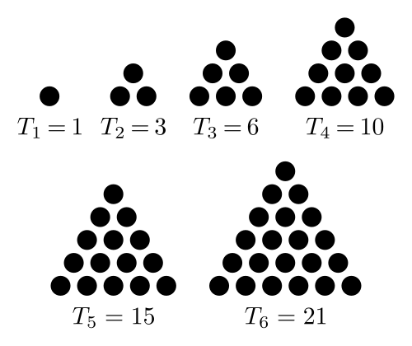
      2. Source: [Generating six pyramidical dots with Latex](https://tex.stackexchange.com/questions/297578/generating-six-pyramidical-dots-with-latex)
2. Choose a number of dots a player can erase per turn, and for now, a general rule of thumb is to choose a number less than half the number of dots.
3. Choose who will go first.
4. Players will then take turns erasing from one to the number chosen earlier.
5. Whoever has to erase the last dot loses.

**Explanation**:

* There are two variables to define:
  + - The total number of dots
 $N$

   - The number of dots a player can erase per turn
  + There are some limitations to the choice of these two to make the game work and/or to make it have some room for error
    - Limitation #1
      * $T > N+2$, or
      * $T-1 > N+1$ (this will make more sense later)
    - Limitation #2
 $N ≥2$     * Though it is possible with $N=1$, it would leave no room for error. The loser is decided by $T$.
        + If $T$ is even, the player to go first wins.
        + If $T$ is odd, the player to go first loses.
* The key to game is modulo operation, which the fancy way of saying finding the remainder of division.
  + To learn more about modulo operation visit [here](https://en.wikipedia.org/wiki/Modulo_operation).
  + Another representation of modulo operation is:
 $\frac{Dividend}{Divisor}=Quotient (and a Remainder)$

   - Modulo operations find and return the remainder of the division.
* To know who will win in this game use the following equation
  + - (Now does $T-1 > N+1$ make sense now?)
  + *Q* is the quotient
  + *R* is the remainder.
  + The solution: *R* is the number of dots to be erased.
  + The -1 in the numerator is due to the fact that the last dot makes the person lose. If the objective of the game was to be the one to erase the last dot, the -1 would not be there.
  + The +1 in the denominator leaves the other the player in the position to lose.
* This same equation can be used no matter what *T* and *N* (if the 2 limitations above are followed), and this equation can be used at any point of the game.
* If *R* is zero from the start, this equation is telling to not erase any dots or the person whose turn it is will lose if the other player does not mess up.
  + This is where some game theory/psychology comes in. Giving the other the choice of going first or second will confuse him or her.
  + If at any point he or she starts to catch the pattern, change *T* or *N* and it will likely throw his or her understanding off. By changing those, it will change whether the person to go first will lose or win.